This PowerShell script aims to monitor the status of network devices in a Meraki network and switch between two different network paths (original and alternate) based on the devices' status.

Here's a step-by-step explanation of each part of the script:

**Set your Meraki API key and network ID:**

The $apiKey and $networkId variables store your **Meraki API key** and **network ID**, which are required for API authentication and specifying the target network.

**Set the endpoint URL for retrieving network status information:**

The $url variable is assigned the endpoint URL for the Meraki API, which retrieves network status information.

**Set the alternate path IP address:**

The $altPath variable stores the IP address of the alternate network path the script will switch to in case of an outage.

**Set the original path IP address:**

The $originalPath variable stores the IP address of the original network path.

**Set the headers for the API request:**

The $headers variable is a **hashtable** that stores the API key under the "X-Cisco-Meraki-API-Key" key, which is required for authenticating API requests.

**Loop until the script is stopped:**

The while ($true) loop is an infinite loop that will continue executing until the script is manually stopped.

**Make the API request:**

The Invoke-RestMethod cmdlet sends an HTTP request to the API endpoint URL specified in $url, passing the headers from $headers. The response is stored in the $response variable.

**Parse the response to extract outage information:**

The $outages variable holds the outage information. It filters the $response using the Where-Object cmdlet to include only the objects with a status that is not **"ok.”**

**Determine the best alternate path to use based on the outage information and set the new route in the routing table:**

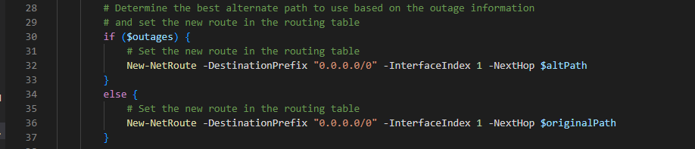

If any outages (the $outages variable is not empty), the script sets the alternate path IP address as the next hop in the routing table using the New-NetRoute cmdlet. Otherwise, it sets the original path IP address as the next hop.

**Loop until the original path becomes available again:**

Another while ($true) loop is used to continuously monitor the original path's availability.

**Determine if the original path is available:**



The Test-Connection cmdlet sends a ping to the original path IP address. The result is stored in the $pingResult variable.

**If the original path is available, switch back to it and exit the loop:**

If the original path is available (the $pingResult is true), the script sets the actual path IP address as the next hop in the routing table using the New-NetRoute cmdlet and breaks out of the inner loop.

**Wait for a short period before checking again:**

The Start-Sleep cmdlet causes the script to pause for 5 seconds before retesting the availability of the original path.

**Handle any errors that occur during the script execution:**

The catch block handles any errors that may occur during the script execution and writes the error message to the console using the **Write-Host** cmdlet.